# Deploy an Azure Kubernetes Service (AKS) cluster

## Check Azure Cli Version

1. Check the azure cli version – should be greater than 2.0.53
2. To check run az –version

## Create a service principal

1.To allow an AKS cluster to interact with other Azure resources, an Azure Active Directory service principal is used

2. Remember we created the Resource group – saketregistry and a ACR within it – saketcontainerregistry and uploaded an image to the registry. If you do not remember or you have not followed the steps, please refer to - **DeployDockerImageToACR(Azure Container registry).docx**

3. AKS cluster will need to communicate with the resource group and the container registry within it and hence a service principal is needed.

4. Run the following command - az ad sp create-for-rbac --skip-assignment

5. The --skip-assignment parameter limits any additional permissions from being assigned. By default, this service principal is valid for one year.

6. Make a note of the appId and password. These values will be used for further steps

## Configure ACR authentication

1. To access images stored in ACR, you must grant the AKS service principal the correct rights to pull images from ACR.
2. You will need to get the ACR resource id- for that run the following command

az acr show --resource-group saketregistry --name saketcontainerregistry --query "id" --output tsv



1. To grant the correct access for the AKS cluster to pull images stored in ACR, assign the AcrPull role. Here in the below command we will need to use the appid and Acr id generated earlier

az role assignment create --assignee <appId> --scope <acrId> --role acrpull

1. We have till now created a service principal, so that we can assign the service principal the role to pull images from the ACR registry. Next step is to set up Kubernetes cluster

## Create a Kubernetes cluster

1. We will now create an AKS cluster within the resource group using the appid and password we generated during creation of service principal. Use a different name to create your cluster.

az aks create --resource-group saketregistry --name SaketAKSCluster --node-count 1 --service-principal <appid> --client-secret <password> --generate-ssh-keys

1. The no of nodes that you want for your cluster – should depend upon the load of your cluster.
2. The command in point no 1 may take more than 10 minutes some times, you can check the portal to see the new activities being performed under your resource group.

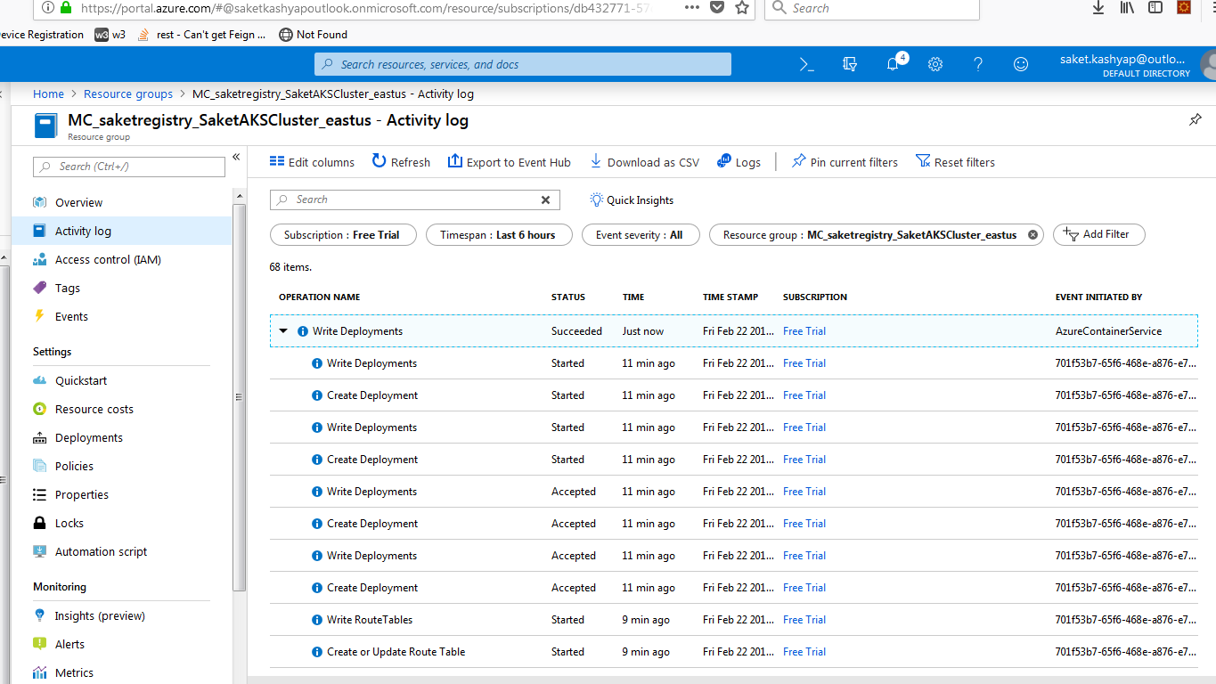

The above image depicts the successful creation of your cluster.

## Install the Kubernetes CLI

1. If kubernetes cli(kubectl.exe) is not installed on your(client) system, install it using the below command - az aks install-cli. Even if you have kubectl already installed and in your path variable, better download it from the above command as there are issues with the kubectl version and the cluster version.
2. To configure kubectl to connect to your Kubernetes cluster(AKS) – use the get credentials command

az aks get-credentials --resource-group saketregistry --name SaketAKSCluster --overwrite-existing



1. After the command is run – you will receive the above message, which means that kubectl is setup to connect to the AKS. You can see the config file of .kube is updated.
2. To check the version of your kubernetes cluster

az aks show --name SaketAKSCluster --resource-group saketregistry --output table

1. Additionally you can configure the current resource group as default group using

az configure --defaults group=saketregistry

1. Then you will not need to set the resource group every time you want to check the resources under it.

**az aks show --name SaketAKSCluster --output table** would be good enough.

1. To list all the clusters that you have access to - az aks list
2. Current problem in listing the nodes

**Kubectl get nodes** – throws an error

**“Unable to connect to the server: x509: certificate signed by unknown authority”**

1. Have raised an issue - <https://github.com/MicrosoftDocs/azure-docs/issues/25536>, please check for resolution if you face the same probs.

* Closed the issue, issue was with the Firewall within the IBM organization. Disconnected the IBM and connected to “IbmInternet”- worked

1. To check all the azure commands - https://docs.microsoft.com/en-us/cli/azure/aks?view=azure-cli-latest